CODEALPHA DATA ANALYTICS INTERNSHIP
COMPLETE PROJECT REPORT
Tasks 2, 3 & 4
Exploratory Data Analysis • Data Visualization • Sentiment Analysis

1. Internship Overview
This report presents three Data Analytics internship tasks: Exploratory Data Analysis, Data Visualization, and Sentiment Analysis. It documents the objectives, datasets, methodology, results, visual outputs, insights and final conclusions.

2. Objectives
- Explore and understand structured sales data.
- Check data quality and identify patterns.
- Create informative charts and a dashboard.
- Analyze review text and classify sentiment.
- Document the work for GitHub and internship submission.

3. Tools Used
- Python
- Pandas
- NumPy
- Matplotlib
- Seaborn

4. Task 2 — Exploratory Data Analysis (EDA)

4.1 Objective
To inspect the sales dataset, understand its structure, check data quality, identify trends and compare category and regional performance.

4.2 Dataset Description
The dataset contains 600 rows and 9 columns: Order_Date, Category, Region, Payment_Method, Quantity, Unit_Price, Discount, Sales, Profit.

4.3 Process
- Load CSV using Pandas.
- Inspect head, shape, information and descriptive statistics.
- Check missing values and duplicates.
- Create monthly sales information.
- Group sales by category and region.
- Generate analytical charts.
- Interpret the results.

4.4 Results
- Total Sales: 564,578.65
- Total Profit: 95,346.82
- Average Order Sales: 940.96
- Missing Values: 0
- Duplicate Rows: 0
- Highest Sales Category: Electronics
- Highest Sales Region: East

4.5 Key Insights
- Electronics is the highest-sales category.
- East is the highest-sales region.
- Monthly analysis shows how sales vary over the year.
- The distribution and box plot show the spread of order sales.
- The correlation matrix helps examine relationships between numeric variables.

4.6 Visual Outputs
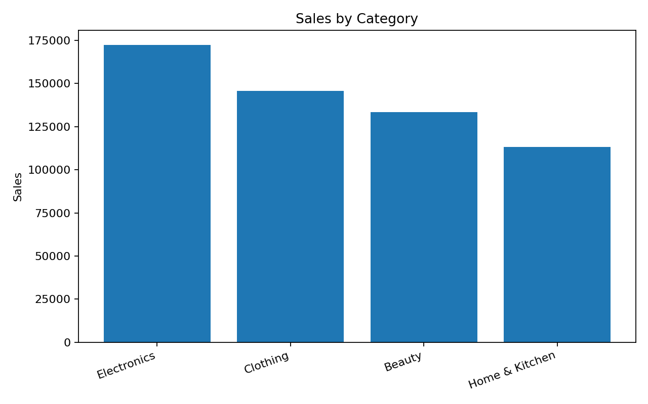
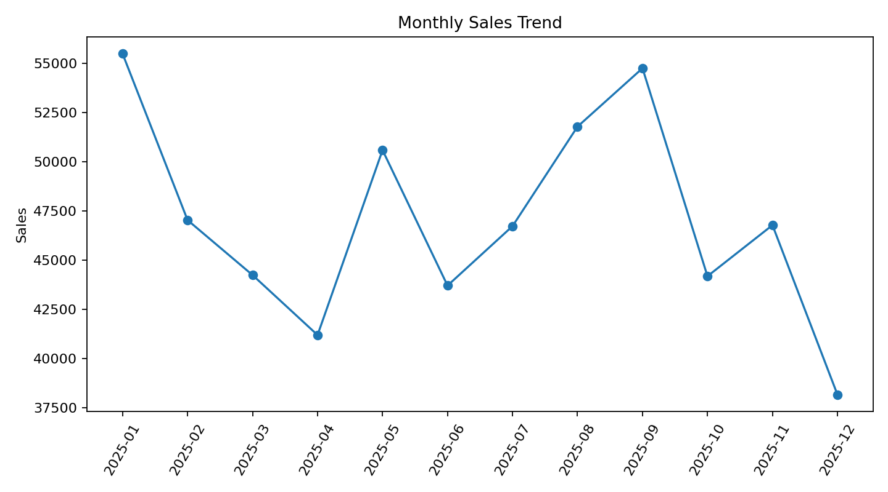
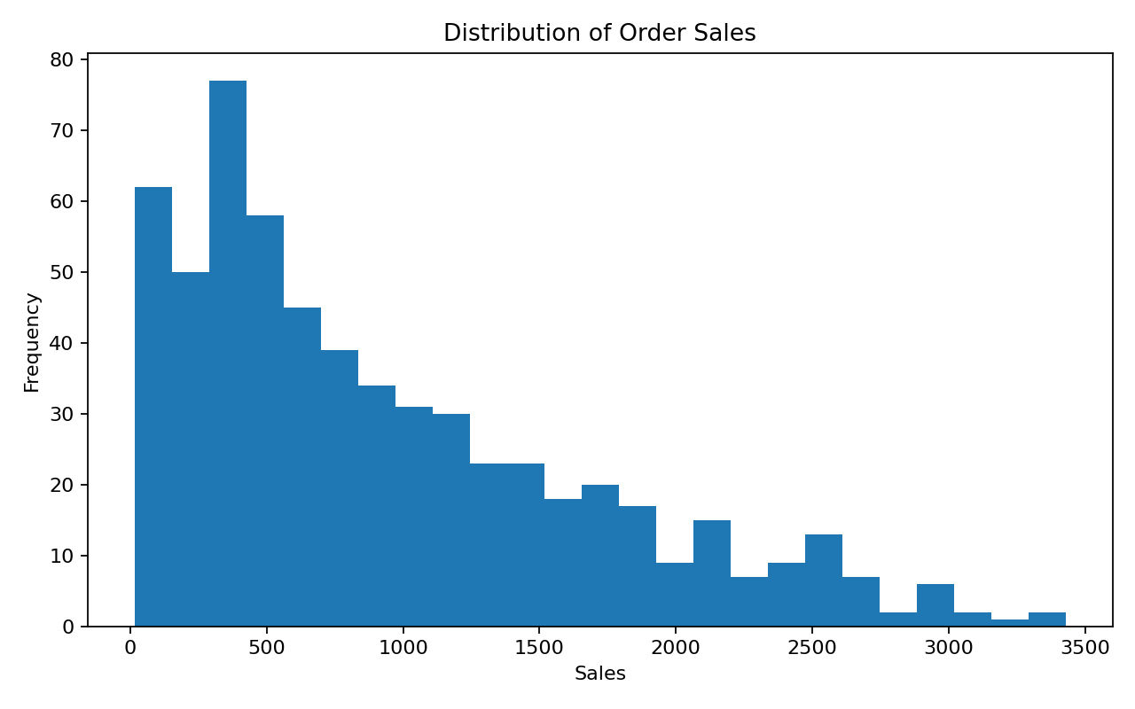
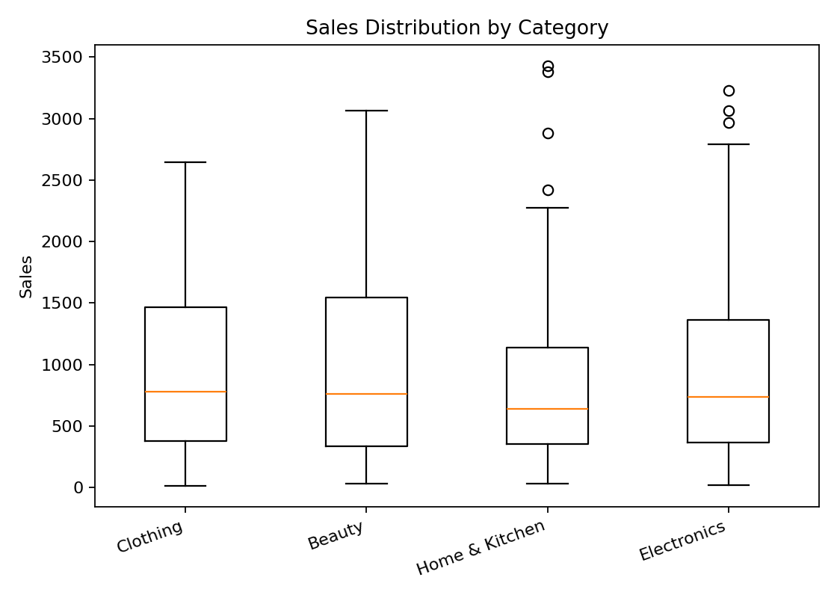
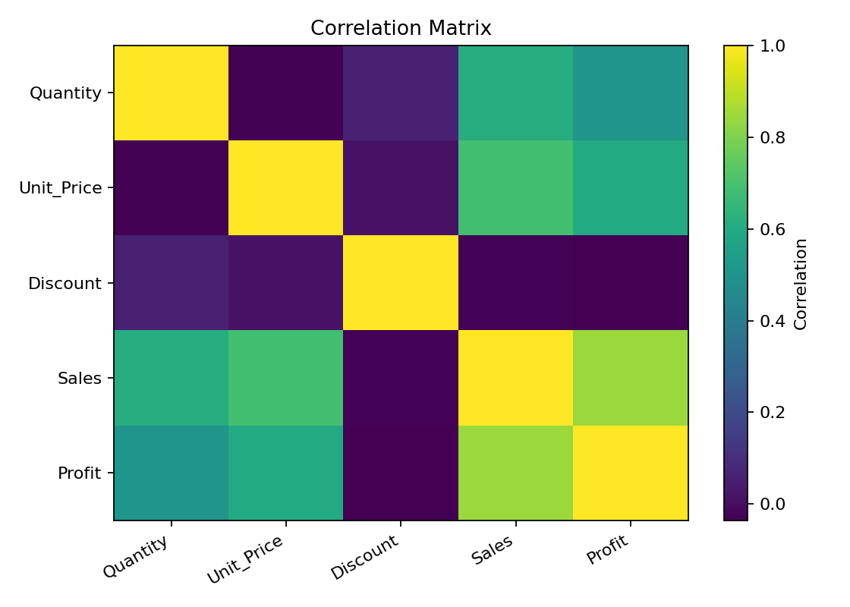

5. Task 3 — Data Visualization

5.1 Objective
To transform sales information into clear visual formats and build a dashboard that communicates key business performance indicators.

5.2 Process
- Calculate total sales, profit and quantity.
- Create KPI cards.
- Create monthly sales trend.
- Compare sales by category.
- Compare sales by region.
- Show payment-method distribution.
- Combine major visuals into a dashboard.

5.3 Dashboard Output
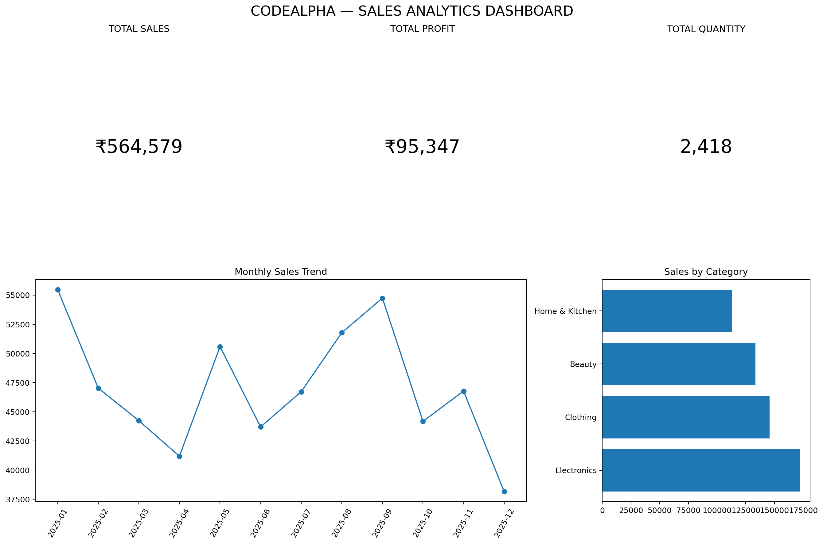

5.4 Insights
- Total Sales: 564,578.65.
- Total Profit: 95,346.82.
- Total Quantity: 2,418.
- Top Category: Electronics.
- Top Region: East.

5.5 Additional Visual Outputs
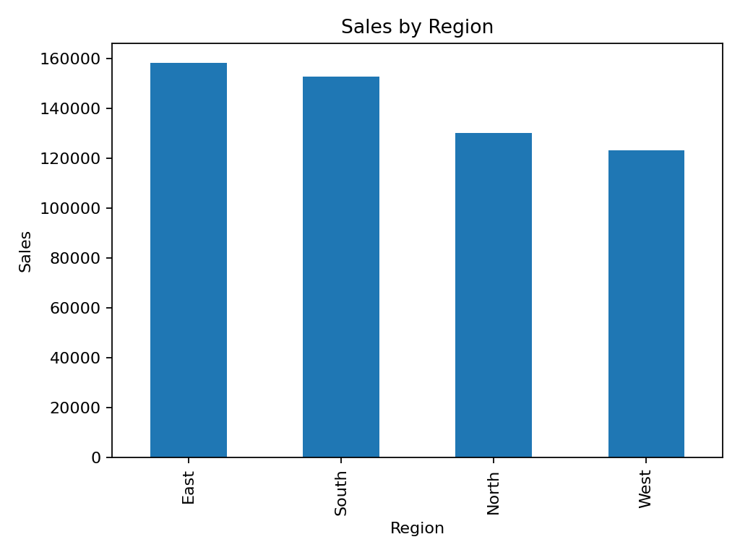
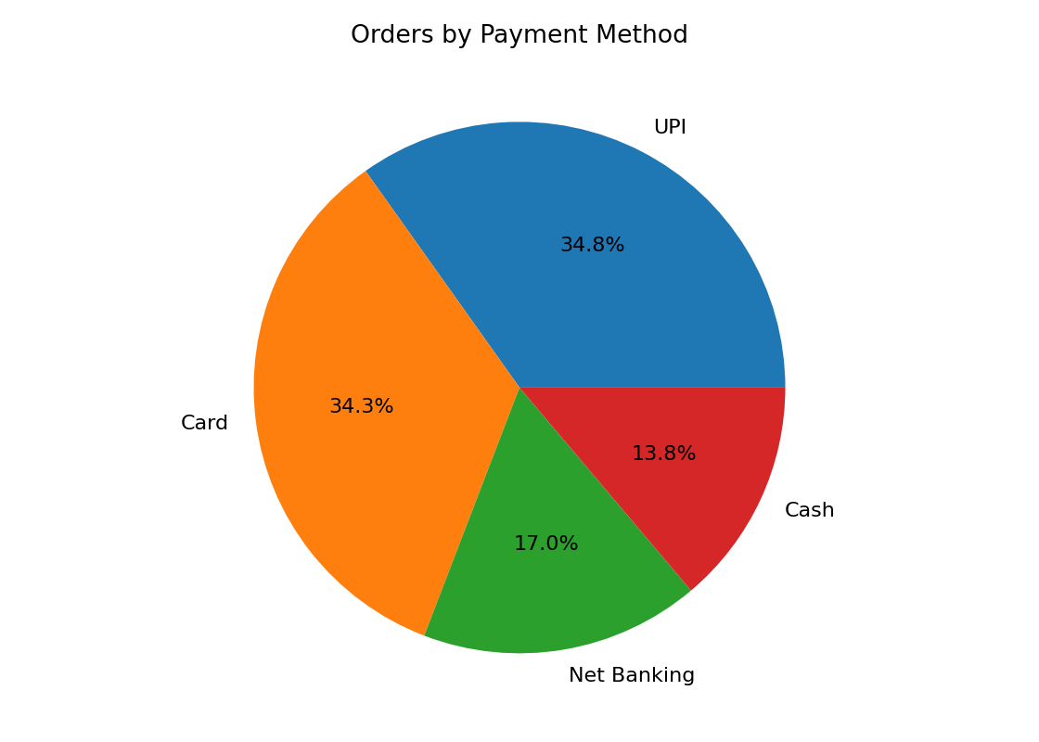

6. Task 4 — Sentiment Analysis

6.1 Objective
To analyze customer review text and classify each review as Positive, Neutral or Negative, then visualize the overall sentiment distribution.

6.2 Dataset
The demonstration dataset contains 15 product reviews.

6.3 Methodology
- Load review data.
- Use a simple positive/negative word lexicon.
- Count matching sentiment words.
- Assign Positive, Negative or Neutral.
- Compare predicted and expected labels.
- Create a sentiment distribution chart.

6.4 Results
- Positive: 5 reviews
- Neutral: 5 reviews
- Negative: 5 reviews
Validation accuracy on this small demonstration dataset: 100.0%.
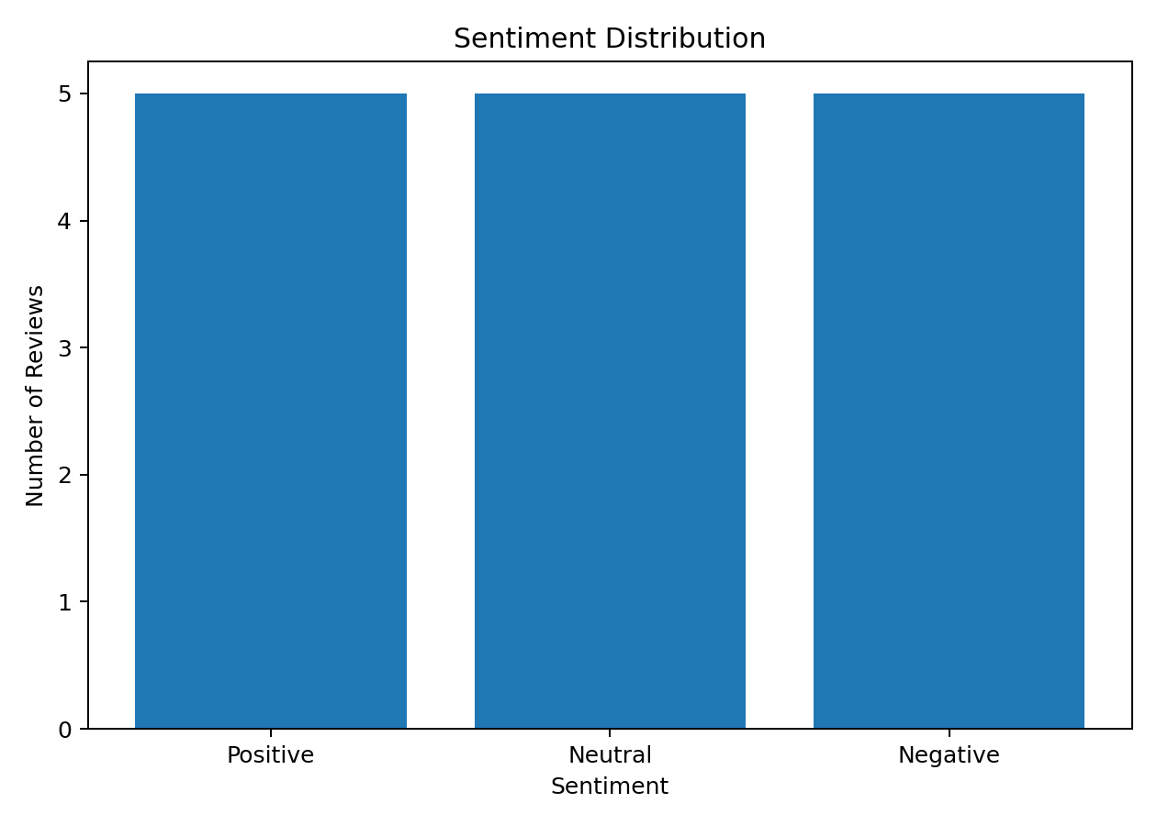

6.5 Insights
- Positive sentiment is the largest group.
- Neutral reviews generally describe average or acceptable experiences.
- Negative reviews mainly mention quality, delivery, damage or service problems.
- The lexicon method is simple and transparent; a larger real-world dataset and stronger NLP method would be appropriate for production use.
7. Overall Conclusion
The three projects demonstrate a complete introductory data analytics workflow: data inspection and exploration, visual communication of insights, and basic natural-language sentiment classification. The work provides practical evidence of Python, Pandas and visualization skills.

Report By –
Y.Vinusha

